**Inspection Request**

1. Form:

* DIV/PACK Re-name it to Description.
* Links to Reports: (Engineering, Material, Procurement Register, Payments, Daily Report, Vendor Register, NCR, Punch List).
* Draft Option should be there in all stages of NCR submission Process.
* Print & PDF
* CC’d Field Must Be there
* A field with two options must be there (the options are: Material or Construction)
* Discipline Field should be there.
* Approve & Reject Buttons to be added, they should interact with NCR report Step #4 in NCR report in case this an inspection agains NCR report (if it is approved/Reject then the action in the NCR will read automatically) – Note: for mor elaboration please contact Hakim

1. List:

* Ability to filter by Discipline.
* Ability to filter by (Material or Construction)
* Show Links Button will be there
* Export to concerns Button.
* Print & PDF.
* Transmittal letter.
* Export & Import Options should be there
* Flag indicator must be there to know what Pending and what is closed
* Assigned to me option must be there.

ss

Construction OR Material

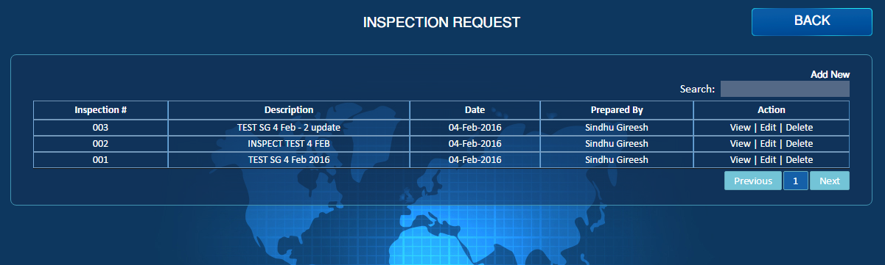

Show Links

Data Date

Assigned to me

Email

PDF

Export to Concerns

Export

Flag Indicator

Discipline

Transmittal Letter

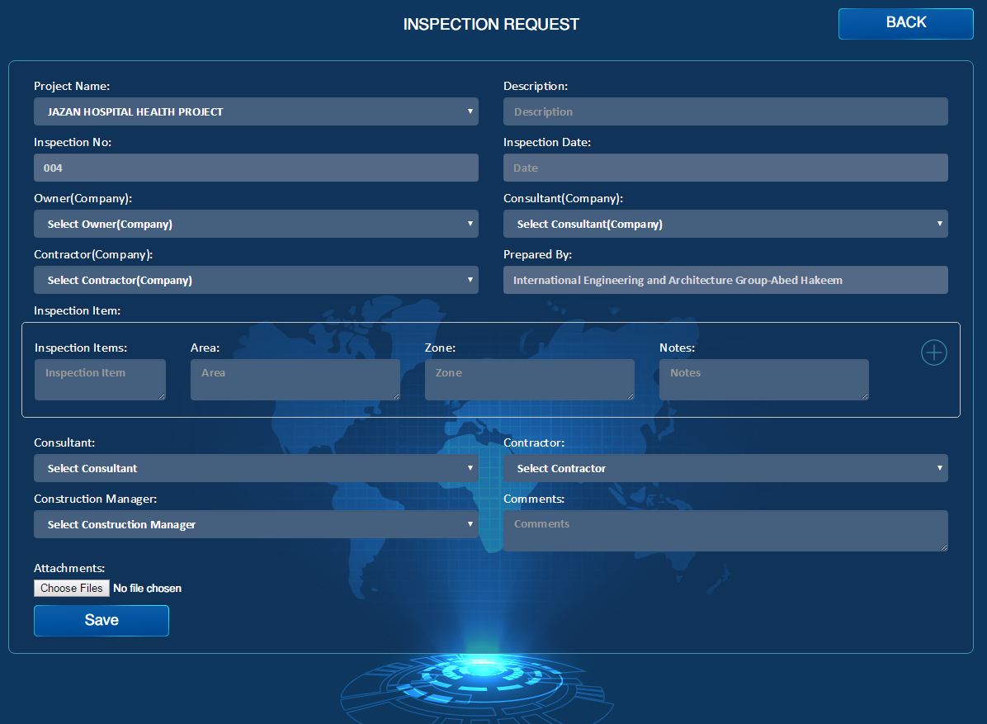

Phase

Reject

Approve

Links

CC’d

Draft

Discipline

Email

Submit

PDF